Protection Review
Please take a moment to assure that your insurance program fully protects your lifestyle and property. With this important but brief questionnaire, you will take the first step in an informative review during which we will help you decide which coverage is best for you. When you are finished you can email, fax or mail this form back to us. At the end of the review you can tell us the best way for one of our team members to get in touch to go over your options. |  |  |  |  |  |  |  | 
Contact Info
After we review your information one of our team members will contact you. Please provide the following information for the person(s) that we should contact.
 |  | Insured |  |  |  | Spouse
Name
Best time to contact
Email Address
Home phone
Work phone
Cell phone
My Personal Insurance Program
In order to properly protect your assets, it is important that we have complete information about all of your insurance coverage that is not written with us. Please provide the following information.
N/A | Policy  Type |  | Date It  Renews | Insurance  Company | N/A |  | Policy  Type |  | Date It  Renews | Insurance  Company
❑ | Auto |  |  |  | ❑ |  | Rental Property
❑ | Home |  |  |  | ❑ |  | Umbrella
❑ | Motorcycle |  |  |  | ❑ |  | Earthquake/Flood
❑ | Recreational Vehicle |  |  |  | ❑ |  | Farm Insurance
❑ | Seasonal Property |  |  |  | ❑ |  | Life Insurance
❑ | Jewelry/Collections |  |  |  | ❑ |  | Health Insurance
❑ | Watercraft |  |  |  | ❑ |  | Business Insurance
❑ | Mobile Home |  |  |  | ❑ |  | Group Health

Protecting Yourself And Your Family
In this section we want to look at areas that will make sure that you preserve the lifestyle for yourself and your family. This includes important areas such as Identity Theft and personal use of cars furnished by employers.
Do you have any jewelry, collections, guns, etc. you would want replaced if they were lost on vacation or if someone broke into your home and stole them? | ❑ Yes   No   I have a question about this |   Did You Know…  A person age 65 today faces a  40% chance of spending time in  a nursing home during their  lifetime.  Taking personality quizzes on  social networking sites such as Facebook could reveal too much information about you and contribute to identity theft?  If you own a business you could  be in danger of losing it should  you or a spouse have an auto accident?  Its great to drive a company car,  but certain limitations could  create problems if you use the vehicle for personal use?
If you had a loss, would you rather have less out of your pocket or would you rather lower your insurance premium by raising your deductible? | ❑ Less out-of-pocket   Lower my premiums   I have a question about this
If you were involved in an accident that was not your fault but the other driver’s insurance was not able to pay for your loss, would you want the money to come from your insurance program?  ________ current uninsured/under insured motorist | ❑ Yes   No   I have a question about this
If you live in an area frequented by flood or earth movement, would you want your property replaced if it were lost due to water damage or earthquake? | ❑ Yes   No   I have a question about this
If you had a chronic illness that left you unable to care for yourself for an extended period of time, would you need money to live? | ❑ Yes   No   I have a question about this
Does anyone in your household drive a car that is furnished by their employer? | ❑ Yes   No   I have a question about this
Do you make purchases over the Internet that requires you to provide personal information such as credit card numbers? | ❑ Yes   No   I have a question about this
In the event of death would you want loans on your vehicles or your mortgage paid? | ❑ Yes   No   I have a question about this

Protecting Other People
This section refers to those individuals involved in an accident that is your fault and you are held responsible to pay for, or replace, damaged property and/or pay for medical bills.
Let’s say you are driving to work tomorrow and had an accident and you were at fault. If there were $300,000 in damages and medical bills would you want this entire amount paid?  ________ Current auto liability limits  ________ Current homeowner liability limits | ❑ Yes   No   I have a question about this |  | 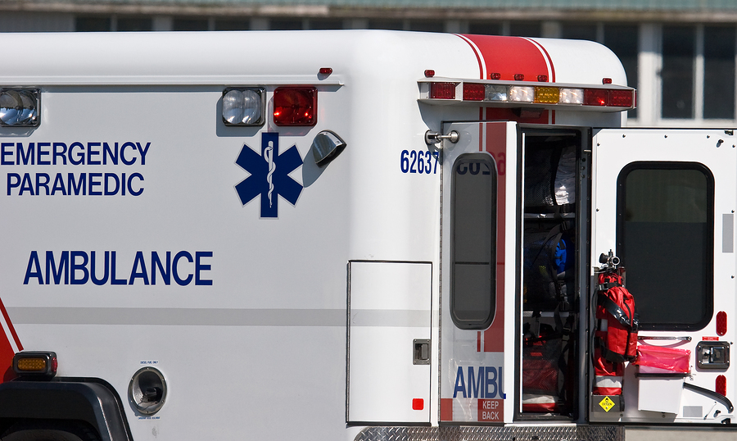  Did You Know…  You don’t have to be a millionaire to be sued like one?
If someone were seriously injured in the accident and sued you for $1,000,000 would you want your insurance to pay the full amount? | ❑ Yes   No   I have a question about this
Your Current Situation
This information will be useful in making certain there has been nothing that has affected your insurance program.
Have you made any improvements or additions to your home over the past five years? |  | ❑ Yes   No   I have a question about this |   Did You Know…  You can often save money by combining your auto and home insurance?  Changes to your life could lower your cost of
Have you made any major purchases over the past five years? For example cars, boats, rental property, vacation homes. |  | ❑ Yes   No   I have a question about this
Have you had a change in your marital status? |  | ❑ Yes   No   I have a question about this
Have you had a change in the number of people living at your home? |  | ❑ Yes   No   I have a question about this
Have you added a burglar alarm or other security devices to your home or auto? |  | ❑ Yes   No   I have a question about this

Do you have a wood burning stove? | ❑ Yes   No   I have a question about this | Did you know…  …that discounts are available for certain professions?  You could be responsible for accidents that might happen to people that come to your home  to pick up products related to your home-based business?  If you have a vacant house, or a property without a house or  other structures, you could have  a problem with your insurance coverage?  Dog attacks on humans,  including those which have resulted in deaths, have become more common?  That your auto insurance rate  could be affected by a student  that is away at college?
Do you have any type of recreational vehicles such as boats, snowmobiles, RV’s, etc.? | ❑ Yes   No   I have a question about this
Do you do any type of farming or have any type of rental property? | ❑ Yes   No   I have a question about this
Do you have drivers under the age of 21? | ❑ Yes   No   I have a question about this
Do you have any drivers away at college? | ❑ Yes   No   I have a question about this
Do you have a trampoline, swimming pool or pets? | ❑ Yes   No   I have a question about this
Do you operate any type of business, including a home-based business? | ❑ Yes   No   I have a question about this
Do you own any vacant houses or property? | ❑ Yes   No   I have a question about this
Do you have any income producing hobbies? | ❑ Yes   No   I have a question about this
Do you serve on any boards, such as at church or other non-profit organizations? | ❑ Yes   No   I have a question about this

Feedback
If any of our team members have provided exceptional service over the past year, please tell us about it.
Questions
Do you have any questions about your insurance program?
Helping Others
If you have benefitted from doing business with us we might also be able to help your friends and neighbors. Who would you suggest we contact?
Name |  | Name
Phone Number |  | Phone Number
Cell Phone |  | Cell Phone
Email address |  | Email address
How do you know them |  | How do you know them

Thank you for the opportunity to review your insurance program. One of our team members will be in touch once they have received your information. Please sign below to confirm that you have provided the information for this review and that no coverage will be in effect until we have received a signed application and all applicable down payments.
_____________________________________ _________________

Property Information
Address |  |  | Other Structures |  | Sq. Feet | Medical  Payments
Garage | Bedroom | Foundation | Bathrooms | Security | Patio/Deck | Plumbing
❑ Attached   Detached   Carport | ❑ 1   2   3   4   5+ | ❑ Slab   Crawl   Finished Bsmt   Unfinish Bsmt | ❑ 1   1 1/2   2   2 1/2   3 | ❑ Dead Bolt   Fire Extgshr   Smoke Detr   Burglar Alarm   Fire Alarm   Sprinklers | ❑ Patio   Deck   Porch   Balcony   Other | ❑ Copper   PVC  Last Update  _____________
Pool | Electrical  Sys | Use | Roof | Type Of Construction | Design | Type of Property
❑ Built In   Above Ground   Diving Board   Fenced   Spa   Jacuzzi | ❑ Breaker   Fuse   Unsure   Copper   Aluminum  Last Update  _____________ | ❑ Primary   Secondary   Vacation   Investment   Other | ❑ Composition   Wood   Tile   Metal   Other  Last Update  _____________ | ❑ Mostly Brick   Mostly Stone   Mostly Wood   Stucco   Veneer   Siding   Other | ❑ One Story   Bi-level   Two Story   Tri-level   Basement | ❑ Single Family   Multi Family   Condominium   Apartment   Townhome   Duplex   Mobile Home   Other

❑ Yes  No | Do you have a fireplace? If yes, how many?
❑ Yes  No | Do you live on acreage? If yes, how many acres
❑ Yes  No | Do you have central A/C? If yes, when was it last updated?
❑ Yes  No | Does anyone in your household smoke?
❑ Yes  No | Are you within the city limits?
❑ Yes  No | Are you within 1000 feet of a fire hydrant?
❑ Yes  No | Is the property within 5 miles of a full-time fire department?
❑ Yes  No | Do you have any detached structure such as a garage, carport, cabana, guest house, etc.?
❑ Yes  No | Do you have a high school or college degree
❑ Yes  No | Do you own your home.
❑ Yes  No
❑ Yes  No

Vehicle Information
Vehicle # 1 | Year | Make | Model | Cost New | VIN # | How Do You Use The Vehicle
Vehicle # 1 |  |  |  |  |  | ❑ Pleasure Only   Business Only   Some Business   Commute To Work ____ miles   Commute To School ____ miles
Vehicle # 1 | Comp  Ded | Coll  Ded | Tow/  Rental | Med/  PIP | Driver
Vehicle # 2 | Year | Make | Model | Cost New | VIN # | How Do You Use The Vehicle
Vehicle # 2 |  |  |  |  |  | ❑ Pleasure Only   Business Only   Some Business   Commute To Work ____ miles   Commute To School ____ miles
Vehicle # 2 | Comp  Ded | Coll  Ded | Tow/  Rental | Med/  PIP | Driver
Vehicle # 3 | Year | Make | Model | Cost New | VIN # | How Do You Use The Vehicle
Vehicle # 3 |  |  |  |  |  | ❑ Pleasure Only   Business Only   Some Business   Commute To Work ____ miles   Commute To School ____ miles
Vehicle # 3 | Comp  Ded | Coll  Ded | Tow/  Rental | Med/  PIP | Driver
Vehicle # 4 | Year | Make | Model | Cost New | VIN # | How Do You Use The Vehicle
Vehicle # 4 |  |  |  |  |  | ❑ Pleasure Only   Business Only   Some Business   Commute To Work ____ miles   Commute To School ____ miles
Vehicle # 4 | Comp  Ded | Coll  Ded | Tow/  Rental | Med/  PIP | Driver

Driver Information
Driver # 1 Name  __________________________ | Driver’s License  Number | Date Of  Birth | Gender | Marital  Status | Relationship | Driver  Info
Driver # 1 Name  __________________________ |  |  | ❑ Male   Female | ❑ Single   Married   Separated   Divorced   Roommate | ❑ Self   Spouse   Son   Daughter   Other | ❑ Defensive Driving   Tickets/Accidents   Licensed revoked   Full-time Student   Require SR-22
Driver # 1 Name  __________________________ | Driver’s Occupation
Driver Information
Driver # 2 Name  __________________________ | Driver’s License  Number | Date Of  Birth | Gender | Marital  Status | Relationship | Driver  Info
Driver # 2 Name  __________________________ |  |  | ❑ Male   Female | ❑ Single   Married   Separated   Divorced   Roommate | ❑ Self   Spouse   Son   Daughter   Other | ❑ Defensive Driving   Tickets/Accidents   Licensed revoked   Full-time Student   Require SR-22
Driver # 2 Name  __________________________ | Driver’s Occupation
Driver Information
Driver # 3 Name  __________________________ | Driver’s License  Number | Date Of  Birth | Gender | Marital  Status | Relationship | Driver  Info
Driver # 3 Name  __________________________ |  |  | ❑ Male   Female | ❑ Single   Married   Separated   Divorced   Roommate | ❑ Self   Spouse   Son   Daughter   Other | ❑ Defensive Driving   Tickets/Accidents   Licensed revoked   Full-time Student   Require SR-22
Driver # 3 Name  __________________________ | Driver’s Occupation

